EE210

Midterm Exam I

10/15/2020

1. [5 5 5 15 pts]

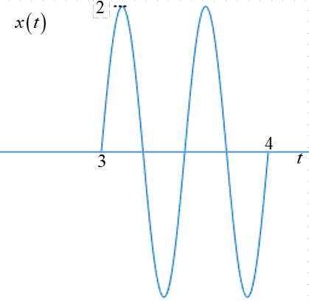

A function,, is shown on the right.



1. Write  (Note: Representing different ways using rect function)
2. Find frequency response of part (a)

|  |  |
| --- | --- |
| a) |  |
| b) |  |
| c) | Plot |

1. Plot magnitude response of part (b), 

|  |  |
| --- | --- |
| a) |  |
| b) |  |
|  |  |

1. [10 10 20 pts]

Two functions are given and 



|  |  |
| --- | --- |
| a) |  |
| b) |  |

1. Write 
2. Plot magnitude and phase of 

|  |  |
| --- | --- |
|  |  |
|  |  |
|  |  |

1. [5 5 10 pts]



Find rectangular and polar format

|  |  |
| --- | --- |
| Rect format |  |
| Polar format |  |

|  |  |
| --- | --- |
| Rect format |  |
| Polar format |  |

|  |  |  |
| --- | --- | --- |
|  |  |  |

1. [8 12 20 pts]

An  is defined as



1. Write frequency response of , 

If this signal,, is sampled with sampling rate of ,

1. Plot magnitude and phase response of  where  (**Note**: make sure you denote the magnitude and phase response scales.)

|  |  |
| --- | --- |
| a) |  |
| b) |  |
|  |  |
| b) |  |

1. [4 pts each 20 pts]

Do the convolution of



Where the range of output, is: note: Just like the quiz you have done, you don’t need to solve the integration, just write low and upper limits and contents inside integrals & output time ranges.

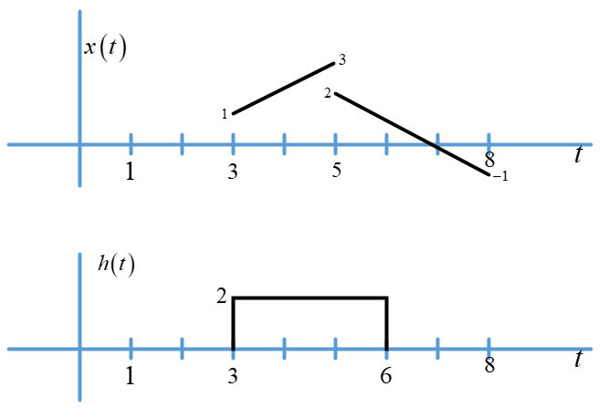

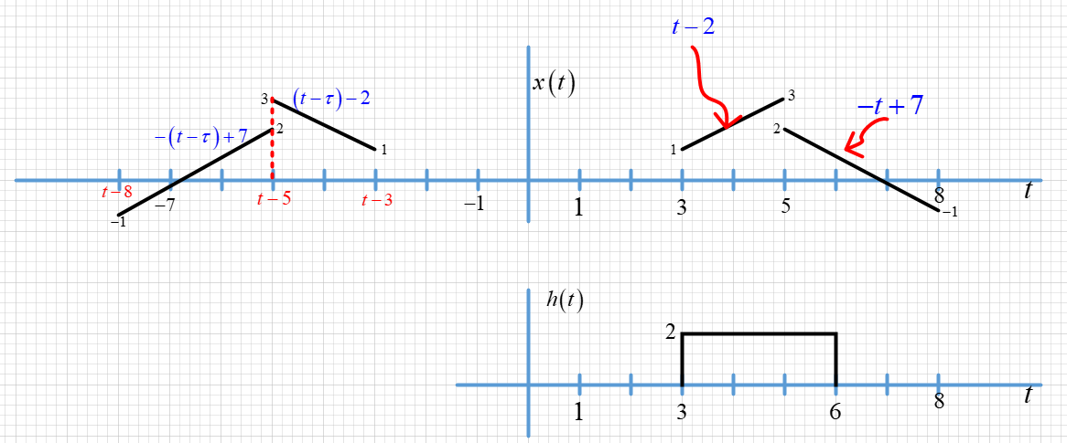

|  |  |  |  |
| --- | --- | --- | --- |
|  |  |  |  |
|  |  |  |  |
|  |  |  |  |
|  |  |  |  |

1. [10 10 20 pts]

A signal  is defined as where is a triangle function

1. Plot 
2. Find frequency response of part (a), . **Note**: You need to represent part (a) triangle function with a convolution of two rectangular functions, one of the rectangular function must be

|  |  |  |
| --- | --- | --- |
| a) |  | |
| b) |  |  |